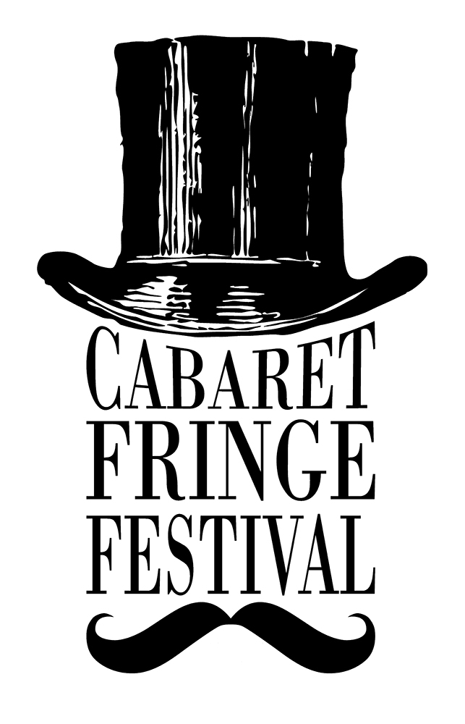
ARTIST REGISTRATION 2016

The following registration form is for artists and companies wishing to participate in the 2016 Cabaret Fringe Festival.

The Cabaret Fringe Festival is an annual open access festival in Adelaide, South Australia. The 2016 Festival will run at various venues around Adelaide from 1st – 26th June 2016.

Cabaret Fringe uses a rolling registration. What this means is that you can register your event at any time and it will be added to the event listings on the Cabaret Fringe website shortly after we receive the completed registration, provided the registration fee has been paid.

Your event will be included in the printed guide if you have registered your event (and paid the registration fee) by 5pm Friday 22nd April. After that, you’ll have an online listing only. But don’t think you can just sit back and take it easy… we’re planning to list a handful of registered events for sale before Easter.

*compulsory information

Contact details

Presenter (e.g. company or artist name):

Primary Contact Person:

Contact Phone:

Email Address:

Web site:

Postal Address:

Have you participated in the Cabaret Fringe Festival before?
Yes No

Social Media
(Please list show-relevant accounts and include full web address, e.g. www.instagram.com/cabfringe)

Facebook:

Twitter:

Instagram:

Financial Information
We require your financial information to enable us to pay your ticketing income to you at the conclusion of the festival.
Presenter Status
Are you a company, collective or sole-trader?:

Entity Name *:

e.g. John Smith (individuals/sole-traders), The Cabaret Collective represented by John Smith (collectives), Peek-a-Boo Productions Pty Ltd (registered company)

ABN*:

Bank Account details

Please check this information carefully!

- Name account is held under:

- Contact Details (if not Presenter/artist)
telephone / email:

- Bank Name *:
e.g. NAB

- Branch Name:
e.g. Hutt Street

- BSB Number *:
e.g. 108-303

- Account Number *:
e.g. 111222333444

Registration Fees:
Up to and including 3 performances = $180
4+ performances = $250
(plus a small .30c TryBooking admin fee)
To pay, please visit this TRYBOOKING link: http://www.trybooking.com/123817

About your production

Title of Show*:

Artists involved (depending on space, these will be included in the Programme Guide):

Description* (show blurb 50 words maximum)

Show duration*:

Content Rating *
What ages is your show suitable for? (please select one option)
- All ages
- 15+
- 18+

Venue *
Have you confirmed a performance venue?
- Yes
- No
If you have not yet confirmed a venue, leave the rest of the Venue section blank. You can provide those details at a later date. Please note that your registration is not complete until you provide your venue and session dates and times.

Venue Name:

Do you have confirmation for all your dates from the venue?
- Yes
- No

Venue Address:

Session Details

Only complete this page if your season (including all session dates/times) has been confirmed with your venue.

Show No. | Performance Date | Time (please indicate AM or PM)
1
2
3
4
5
6
7
8
9
10

If you’re presenting more than 10 performances, please contact us with the details.

Venue maximum capacity (i.e. the maximum number of seats the venue/space can hold):

Maximum performance capacity (i.e. the number of seats available for your performance):

Ticket Types
- Enter below each ticket type you wish to make available for purchase.

Please note: all ticket prices listed must be inclusive of fees and charges of $3.30 per ticket. Minimum requirement is Adult, although we do encourage concession-pricing options.

- If your event is free, write "Free" in the Full Price box

- Please note: Cabaret Fringe participates in the Companion Card scheme for all performances. Companion Card is a card issued to people with a permanent disability who require attendant care support which allows a companion to enter free of charge when the person with a disability has a valid ticket.

Ticket Type | Ticket Price
Adult* | $
Concession (Student / Pensioner / Unemployed) | $
TREv  Discount price for 18-30 year old members of TREv (www.trev.com.au) | $
Groups (available for group bookings of 6) | $
Artist (discount price available to other Cabaret Fringe artists & members) | $
Child (Under 14 years) | $
Other ticket type (e.g. Early bird, special, etc) | $
Complimentary (media, family or friends) | Free

Complimentary Tickets
You may wish to set aside a number of tickets to give away as comps to family and friends.

Please indicate the number of comps you would like set aside per performance here:

Media Tickets
Do you authorise Cabaret Fringe to issue complimentary tickets to media outlets for review
purposes? Please note, not all shows may be reviewed.
Do you have any special instructions regarding media ticketing?
Yes No
If yes, please provide details:

Promotional Details
The following information or promotional materials are required by the Cabaret Fringe Festival to sell your show to the public. Some information is essential (indicated with a * Required). Other information is useful in promoting your event.

Please tick the box below if you are able to provide the content:

- * Event Image (300dpi, minimum 1000 pixels wide/high)
- Artist Biographies (150 t0 200 words max)
- Other promotional photos, other than event image (png or jpeg images)
- Show Reel videos (provide online link or low resolution copy)

All photographs, short videos and documents may be deposited in the Cabaret Fringe Drop Box or emailed to info@cabaretfringefestival.com.

Enquiries about the requested promotional information should be made to Eugene via the above email address.

Terms & Conditions
Conditions of Cabaret Fringe Festival Registration:
- The number of performances, session times and venue are solely at the discretion of the organisers/venues.
- The Cabaret Fringe Festival logo will appear on all printed material promoting your event.
- Any images provided for use in the Cabaret Fringe Festival program are provided with full permission of the copyright owner
- A limited number of tickets may be held for Sponsors of the Cabaret Fringe Festival and Press Reviewers etc. this will be limited to 4 tickets per performance unless additional permission is given. Tickets will not be unreasonably withheld or demanded by either party.
- In the event of event cancellation a representative of the Event will be present at the advertised time and venue to apologise to any members of the public who may attempt to attend the event.
- Registered participants agree to complete a Cabaret Fringe Event Survey at the completion of the Festival.
- All venue hire and technical hire & staff costs are the responsibility of the presenter (artist/company)
- Cabaret Fringe Festival does not manage venues or seasons. It is the responsibility of the artist/presenter to make all arrangements directly with venue.
- Submission of this form and payment of the registration fee constitutes an agreement to perform the Event as outlined in this document. Cancellation of the Event is entirely at the discretion of the Festival/Venue and fees are not refundable.

Confirmation of Terms *

I have read the conditions of registration and AGREE

I have read the conditions of registration and DO NOT AGREE

Confirmation of Artists Information *

Before you submit, you must read "Artists Information" document

Yes, I have read the document

No, I haven't read the document
Bottom of Form

Signed by the Presenter:

PRINT NAME:

COMPLETED THE FORM?

Return it to Cab Fringe via:
- Email to info@cabaretfringefestival.com
- Post to 79 Wilpena Tce, Kilkenny SA 5009

PLEASE REMEMBER TO RETAIN A COPY FOR YOUR OWN RECORDS.

