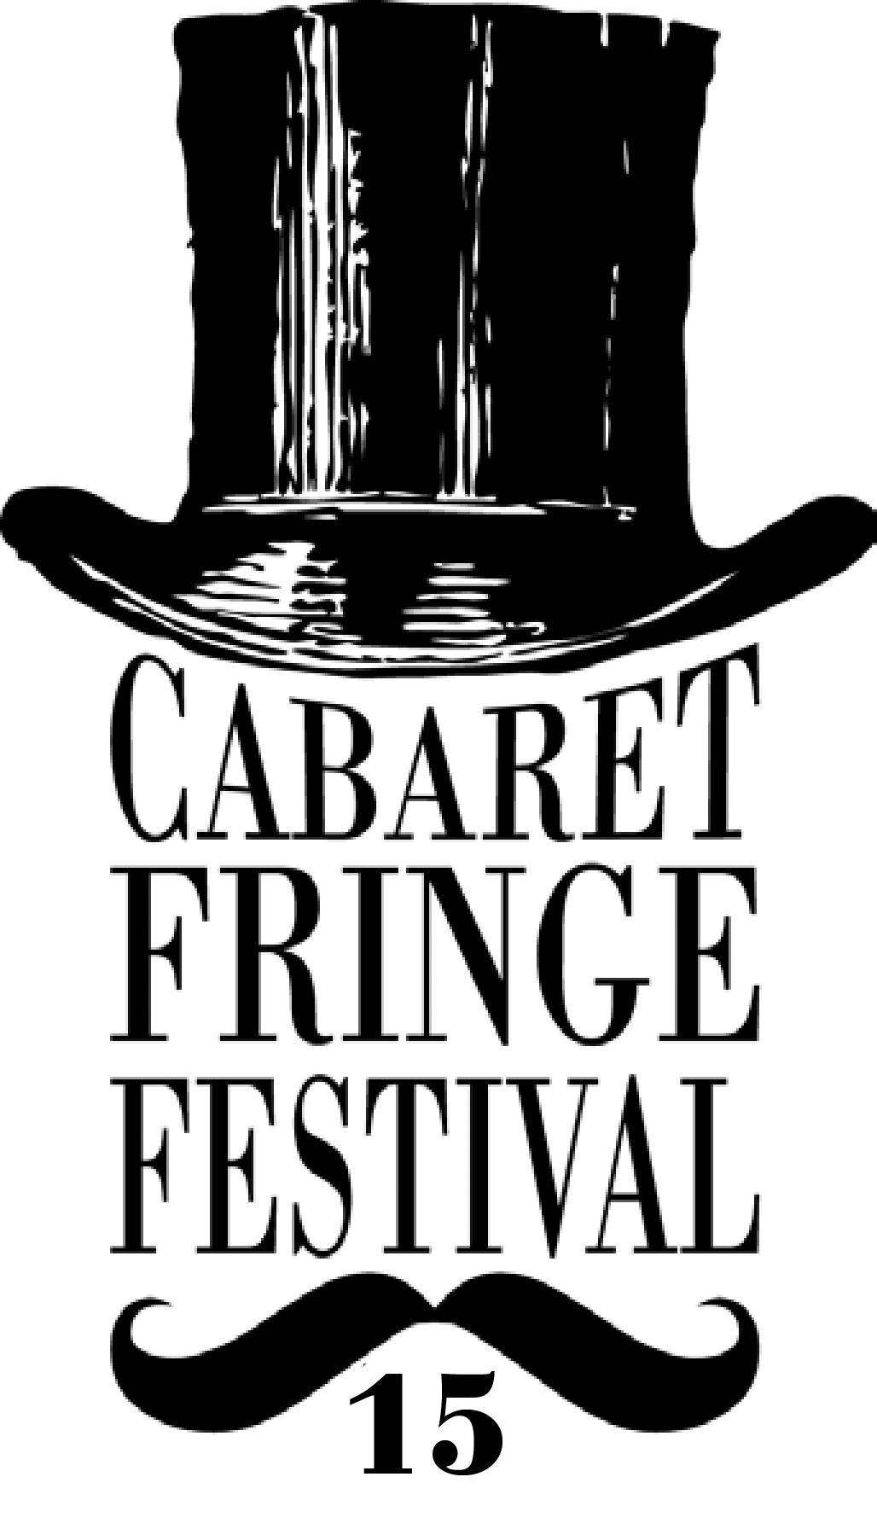

ARTIST REGISTRATION 2015

The following registration form is for artists and companies wishing to participate in the 2015 Cabaret Fringe Festival.

The Cabaret Fringe Festival is an annual open access festival in Adelaide, South Australia. The 2015 Festival will run at various venues around Adelaide from 30 May to the 28 June 2015.

Please note that programming is at the discretion of the venues involved. It is up to the artists and venues to negotiate directly.

** Cabaret Fringe Registrations are now a Rolling Registration ** What this means is that you can register your event at any time and it will be added to the event listings on the Cabaret Fringe website shortly after we receive the registration.

You can still get in the printed guide if you have registered your event by Friday 25 April. After that, you’ll have an online listing only. But don’t think you can just sit back and take it easy… we’re planning on listing the first ten registered events for sale before Easter.

*compulsory information

Contact details

Presenter : ……………..…………………… Primary Contact : ………………………………….

Role : …………………………………………. Contact Number : …………………………………

Email Address : ………………………………………………………………

Web site : ………………………………………………………………………..

Postal Address : …………………………………………………………………………………………………

…………………………………………………………………………………………………

Have you ever participated in the Cabaret Fringe Festival before?
Yes No

Financial Information
We require your financial information to enable us to pay your ticketing income to you at the conclusion of the festival.
Presenter Status
Are you a company, collective or sole-trader? : ……………………………………………………….

Entity Name * : ……………………………………………………
ABN no * : ……………………………………………………………..

e.g. John Smith (individuals/sole-traders), The Cabaret Collective represented by John Smith (collectives), Peek-a-Boo Productions Pty Ltd (registered company)

- Financial Contact (leave blank if the details are the same as the presenter)

Full Name : …………………………………………………………..

- Contact Details
telephone / email : ………………………………………………..

- Bank Name * : ………………………………………………………
e.g. NAB

- Account Name * : …………………………………………………..
e.g. Mr John Smith

- Branch Name : ………………………………………………………..
e.g. Hutt Street

- BSB Number * : ………………………………………………….…..
e.g. 108-303

- Account Number * : ………………………………………………...
e.g. 111222333444

About your production

Title of Show : …………………………………………………………………………………………………..…..

Artists : ……………………………………………………………………………………………………….

Description (show blurb 50 words absolute max)

………………………………………………………………………………………………………………………….

………………………………………………………………………………………………………………………….

………………………………………………………………………………………………………………………….

………………………………………………………………………………………………………………………….

………………………………………………………………………………………………………………………….

Content Rating *
What ages is your show suitable for? (please tick)
- All ages
- 15+
- 18+
Registration Fees: up to 3 performances = $180, 4+ performances = $250 (plus a small .30c charge from trybooking)
To pay please visit this TRYBOOKING link : http://www.trybooking.com/123817

Venue *
Have you confirmed a performance venue?
- Yes
- No
Only complete this page if your season (including all session dates/times) has been confirmed with your venue.

Venue Name : ………………………………………………………………………………………………………..

Do you have confirmation for all your dates from the venue?
- Yes
- No
Venue Address : …………………………………………………………………………………………………….

…………………………………………………………………………………………………….

Performance Date - # 1 *  DD Mon YYYY |  | Time - # 1 *  h:mm AM/PM
Performance Date - # 2*  DD Mon YYYY |  | Time - # 2 *  h:mm AM/PM
Performance Date - # 3*  DD Mon YYYY |  | Time - # 3 *  h:mm AM/PM
Performance Date - # 4*  DD Mon YYYY |  | Time - # 4 *  h:mm AM/PM
Performance Date - # 5*  DD Mon YYYY |  | Time - # 5 *  h:mm AM/PM
Performance Date - # 6*  DD Mon YYYY |  | Time - # 6 *  h:mm AM/PM
Performance Date - # 7*  DD Mon YYYY |  | Time - # 7 *  h:mm AM/PM
Performance Date - # 8*  DD Mon YYYY |  | Time - # 8 *  h:mm AM/PM
Performance Date - # 9*  DD Mon YYYY |  | Time - # 9 *  h:mm AM/PM
Performance Date - # 10*  DD Mon YYYY |  | Time - # 10 *  h:mm AM/PM
Performance Date - # 11*  DD Mon YYYY |  | Time - # 11 *  h:mm AM/PM
Performance Date - # 12*  DD Mon YYYY |  | Time - # 12 *  h:mm AM/PM

Venue maximum capacity : …………………..

Maximum performance capacity : ……………………

If you have not yet confirmed a venue, fill out as much of this form as you can and provide your venue details at a later date. We will follow also follow up with you at a later date.

Ticket Types
- Enter below each ticket type you wish to make available for purchase and the value in AUD$. Please note: all ticket prices listed must be inclusive of fees and charges of $3.30 per ticket. Minimum requirement is Adult, although we do encourage concession-pricing options.

- If your event is free, write "Free" in the Full Price box (Note: bookings can be made for free events at no charge).
- Please note: Cabaret Fringe participates in the Companion Card scheme for all performances. Companion Card is a card issued to people with a permanent disability who require attendant care support which allows a companion to enter free of charge when the person with a disability has a valid ticket.

Ticket Type | Ticket Price
Adult* | $
Concession  Student / Pensioner / Unemployed | $
Trev Trev  Discount price for 18-30 year old members of Trev (www.trev.com.au) | $
Groups  available for group bookings of 6+ | $
Artist/Members  discount price available to other Cabaret Fringe artists & members | $
Child  Under 14 years | $
Other ticket type

Complimentary (media, family or friends) | Free

Complimentary Tickets
You may wish to set aside a number of tickets to give away as comps to family and friends, and/or to the media. Please indicate the number of comps you would like set aside per performance in the complimentary category above.

Media Tickets
Do you authorise Cabaret Fringe to issue complimentary tickets to media outlets for review
purposes? Please note, not all shows may be reviewed.
Do you have any special instructions regarding media ticketing?
Yes No

Promotional Details
The following information or promotional materials are required by the Cabaret Fringe Festival to sell you show to the public. Some information is essential (indicated with a * Required). Other information is useful in promoting your event.

Please tick the box below if you are able to provide the content:

- * Event Image (300dpi, minimum 1000 pixels wide/high)
- Artist Biographies (150 t0 200 words max)
- Headshots of key artists (png or jpeg images
- Show Reel videos (provide online link or low resolution copy)

All photographs, short videos and documents may be deposited in the Cabaret Fringe Drop Box or emailed to info@cabaretfringefestival.com

Enquiries about the requested promotional information should be to Tracey or Eugene via the above email address.

Top of Form

Terms & Conditions
Conditions of Cabaret Fringe Festival Registration:
- The number of performances, session times and venue are solely at the discretion of the organisers/venues.
- The Cabaret Fringe Festival logo will appear on all printed material promoting your event.
- Any images provided for use in the Cabaret Fringe Festival program are provided with full permission of the copyright owner
- A limited number of tickets will be held for Sponsors of the Cabaret Fringe Festival and Press Reviewers etc. this will be limited to 4 tickets per performance unless additional permission is given. Tickets will not be unreasonably withheld or demanded by either party.
- In the event of event cancellation a representative of the Event will be present at the advertised time and venue to apologise to any members of the public who may attempt to attend the event.
- Registered participants agree to complete a Cabaret Fringe Event Survey at the completion of the Festival.
- All venue hire and technical hire & staff costs are the responsibility of the presenter (artist/company)
- Cabaret Fringe Festival does not manage venues or seasons. It is the responsibility of the artist/presenter to make all arrangements directly with venue.
- Submission of this form and payment of the registration fee constitutes an agreement to perform the Event as outlined in this document. Cancellation of the Event is entirely at the discretion of the Festival/Venue and fees are not refundable.

Confirmation of Terms *

I have read the conditions of registration and AGREE

I have read the conditions of registration and DO NOT AGREE

Confirmation of Artists Information *

Before you submit, you must read "Artists Information" document

Yes - I have read the document

No I haven't read the document
Bottom of Form

Signed by the Presenter : ………………………………………………….

PRINTED NAME : …………………………………………………………...

