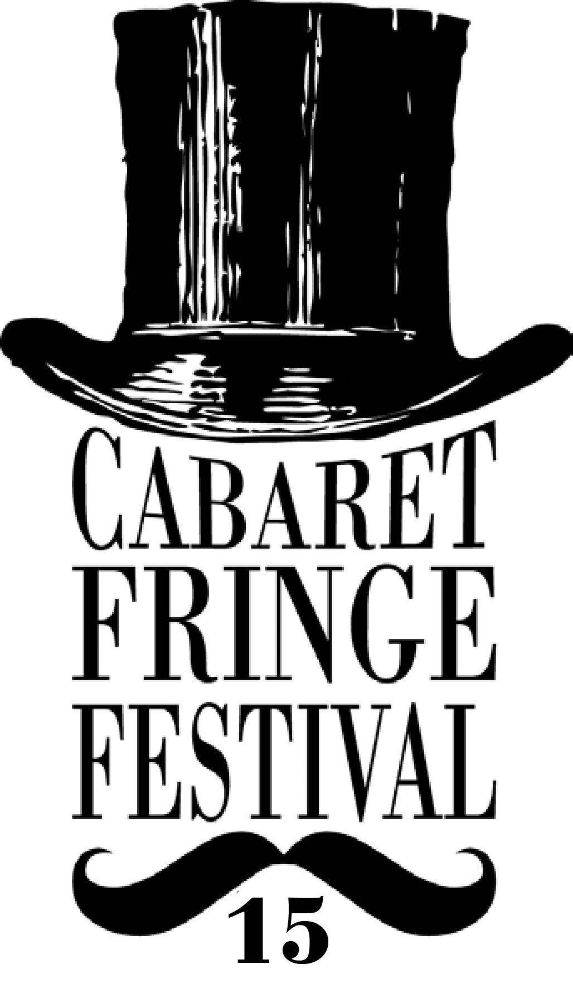

VOLUNTEER APPLICATION 2015

The following application form is for volunteers wishing to participate in the 2015 Cabaret Fringe Festival.

The Cabaret Fringe Festival is an annual open access festival in Adelaide, South Australia. The 2015 Festival will run at various venues around Adelaide from 30 May to the 28 June 2015.

This year you can assist the Cabaret Fringe Festival working with either a venue or the Cabaret Fringe team staff within three areas:
1. Front of House: Are you keen to help out in a Front of House position within a Cabaret Fringe Venue or at a Cabaret Fringe event?
2. Production: Care to help out backstage, with sound, coordination or lighting?
3. Promotions: Become part of the Cabaret Fringe Team of promotional staff, visiting local Adelaide events to hand out fliers and talk up Adelaide’s very own Cabaret Fringe Festival.
Other roles may arise on a per needs basis.

Currently enquiries should be sent to Dahlia Opala via info@cabaretfringefestival.com

Registrations close strictly May 8 2015.
Please note that we will do our best to place you, however, there are only limited positions available. All applicants will be notified via email in regards to the success of their registration.

- A Volunteer Agreement form will need to be signed if you are selected to join our Volunteer Team. This will be sent to you with your acceptance letter.
- Successful applicants will be invited to attend a Welcome and Information session on Wednesday May 20th. Venue and time TBC.

Photo
Please attach a headshot with your email or hard copy application, no larger than 1.5MB. For those of you mailing an application via snail mail you may email a photo to info@cabaretfringefestival.com please ensure you name the file with both your first and second name. A photo will help staff to identify you.

Contact details

Full name: ………………………………………………… Mobile: ……………………………………………….

Email: …………………………………………………………………………………………

Address: ……………………………………………………………………………………………………………………..

………………………………………………………………………………………………………………………….

Age group:
18-24 25-34 35-44 45-54 55+
T-shirt size:
Male S M L XL other Female S M L XL other
Why would you like to be a volunteer for the 2015 Cabaret Fringe Festival?

………………………………………………………………………………………………………………………….

………………………………………………………………………………………………………………………….

………………………………………………………………………………………………………………………….

………………………………………………………………………………………………………………………….

………………………………………………………………………………………………………………………….

Do you have any health or physical concerns, which we should know about (e.g. Asthma, allergies, mobility) so that we can help make your experience safe and enjoyable?

………………......................................................................................................................................

........................................................................................................................................................

........................................................................................................................................................

Skills and experience (please add detail where applicable)
Administration/IT/Computer (Excel, Social Media):

………………......................................................................................................................................

........................................................................................................................................................

........................................................................................................................................................
Front of House/Customer Service (door staff, hosts, ticketing):

………………......................................................................................................................................

........................................................................................................................................................

........................................................................................................................................................

Production (sound, lighting, stage management, backstage coordination):

………………......................................................................................................................................

........................................................................................................................................................

........................................................................................................................................................

Promotions:
………………......................................................................................................................................

........................................................................................................................................................

........................................................................................................................................................

Are there any other skills, which you would like to share with us or develop during your volunteering duties at Cabaret Fringe Festival?

………………......................................................................................................................................

........................................................................................................................................................

........................................................................................................................................................

Availability (please specify particular times you are available)

DAY | AM | PM
MONDAY

TUESDAY

WEDNESDAY

THURSDAY

FRIDAY

SATURDAY

SUNDAY

Please note that in most instances we would not ask you to volunteer for more than 4 hours in a day.

Photography
Do you permit the Cabaret Fringe Festival to use images taken of you during volunteering duties to be included for promotional opportunities (Social Media, advertising etc.)

Signature of applicant : ……………………………………………

Thank you.

Please return completed form to Dahlia Opala by 8th May 2015

Email: info@cabaretfringefestival.com

Snail Mail: La Boheme Bar
36 Grote St
Adelaide SA, 5000

Top of Form

Bottom of Form

