Presenting

CANDY CHAMBERS – 50 FOREVER!

13 & 19 June, 9pm | 14 & 21 June, 7pm
ADULTS $35 | Concession $25

@ The Soul Box, 252 Hindley St, Adelaide

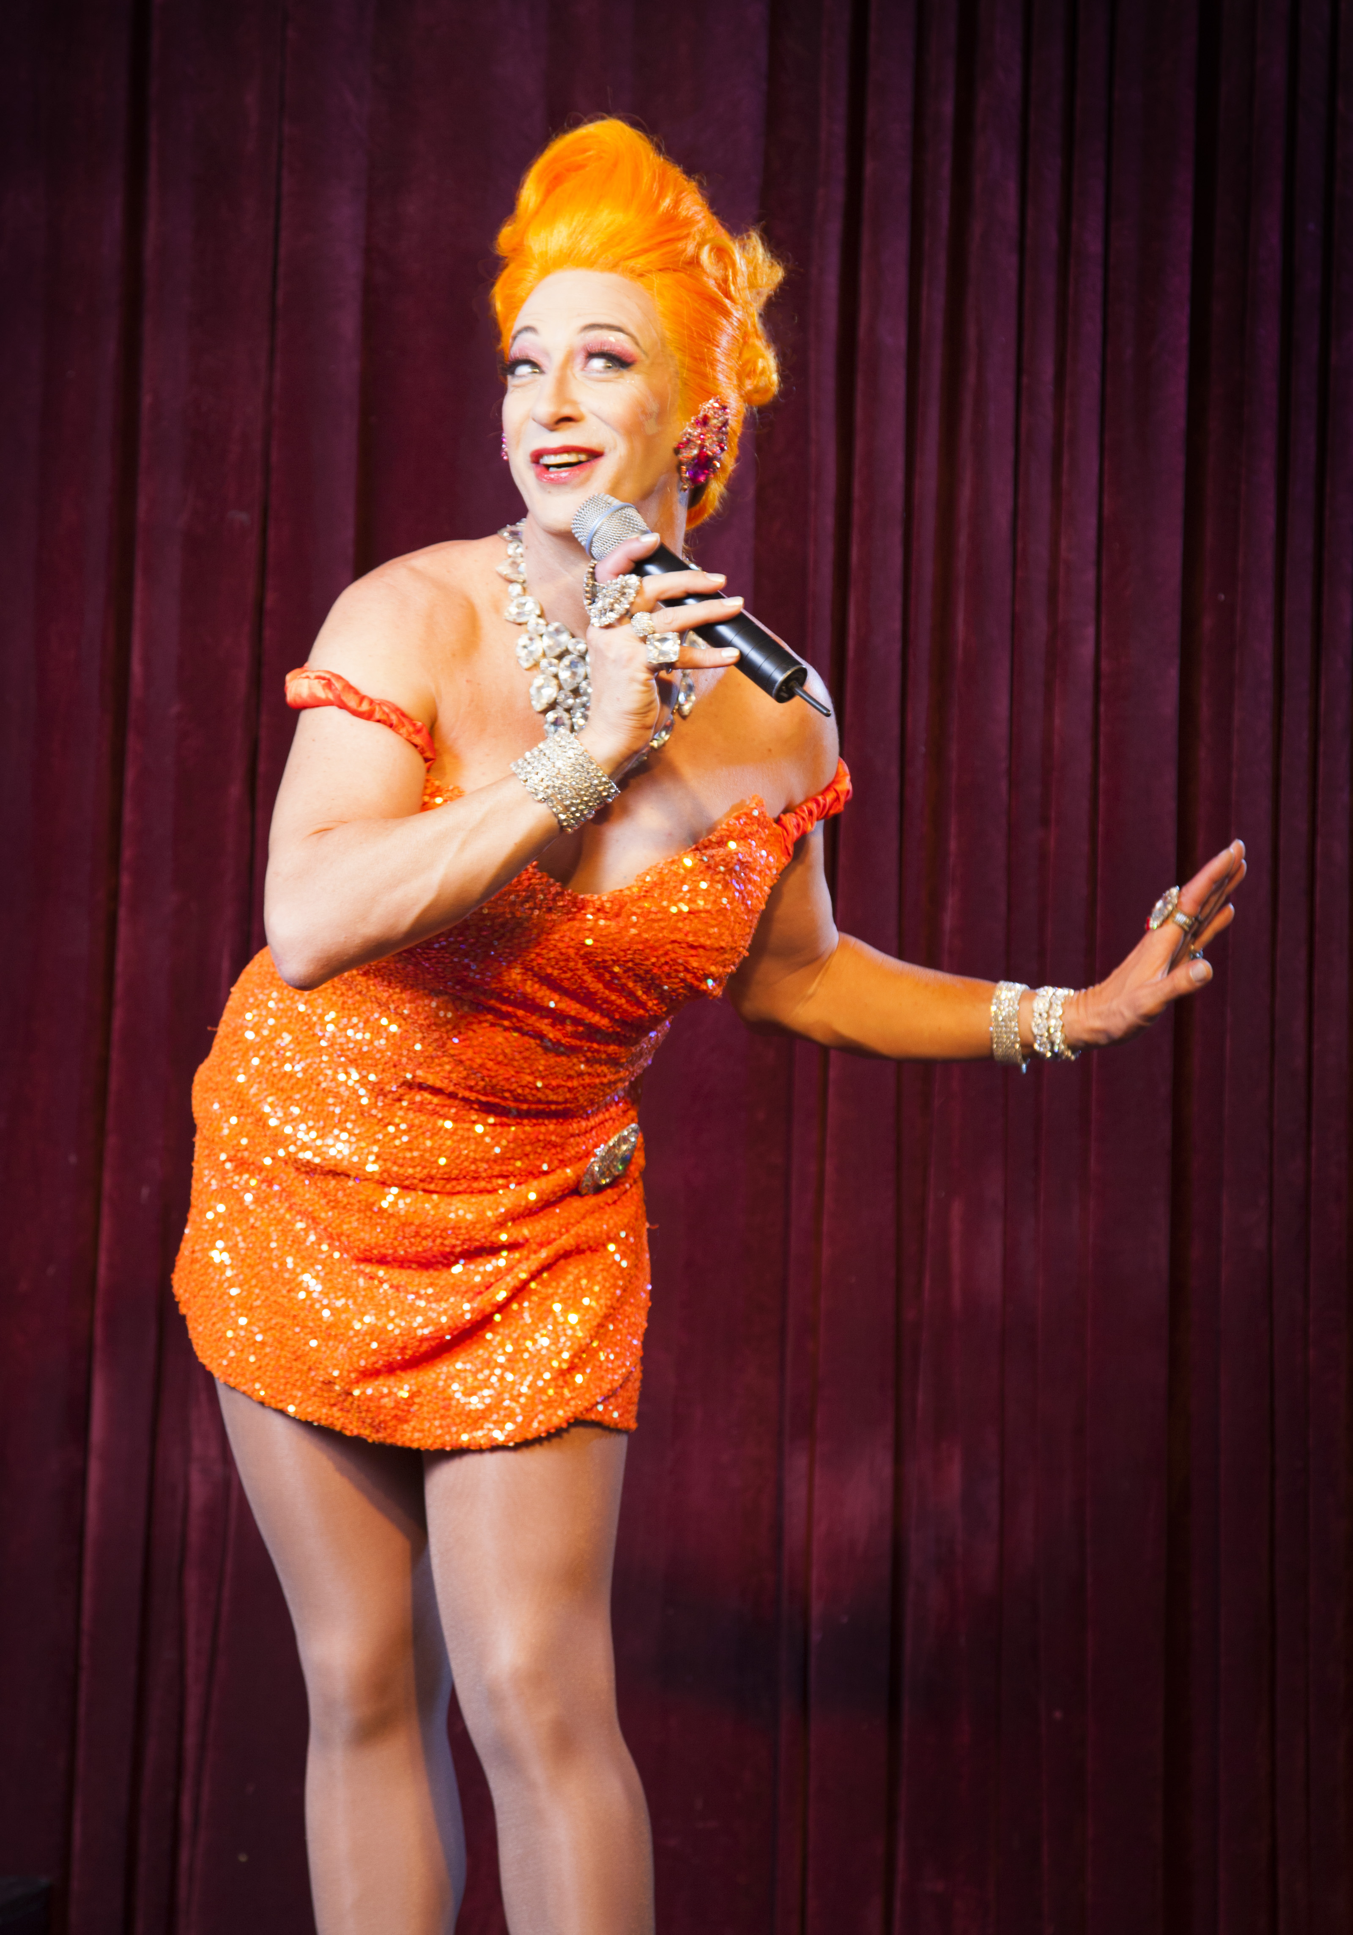
Candy Chambers presents colour and charisma like no one else can – and she’s showing no signs of turning the brightness down.
Some say that turning 50 is the marker of middle age. Candy has other ideas involving a truckload of sequins and the true story of a good girl gone bad made good.

Baring her soul on the stage for all to see in 50 Forever! Candy Chambers wears her chequered past as a badge of honour: the double manslaughter of her former fiancé and best friend, her highly lauded career in the adult entertainment industry. No scandal too great has thwarted this songbird’s sense of innocence, poise and charm.

Now she’s back to enchant all her faithful Adelaide fans and entice new admirers with 50 Forever! - the philosophies and wisdoms of a Chattanooga chanteuse.
“My story is one of triumph over adversity. I am an authentic success because I have really come along; I believe that my story will touch all kinds of people, as I like to do.”

Any Marcia Hines-loving, Charlie’s Angels-adoring, bluesy pop music-listening independent women absolutely must make a date with Candy Chambers in 50 Forever!

“Sweet, melodic, funny and fashionable… No wonder I’ve got a Candy Crush.” GLAM Adelaide
“Go to see '50 Forever' for a smile, a giggle and to see a 50 year old glamour puss on a stripper pole.” SA Weekend Notes

International singer, dancer and performer Jamie Jewell is Candy Chambers. Jewell featured in Baz Luhrmann’s Moulin Rouge!, toured for three years with CATS and most recently finished among the final 12 hopefuls in Channel 10’s I Will Survive.

"I have certainly met my fair share of celebrities. I had quite a night with Ewan McGregor, but I dont kiss and tell.”

Media contact: Candy.Chambers61@gmail.com or Karen Raymond (0403 992 239)

