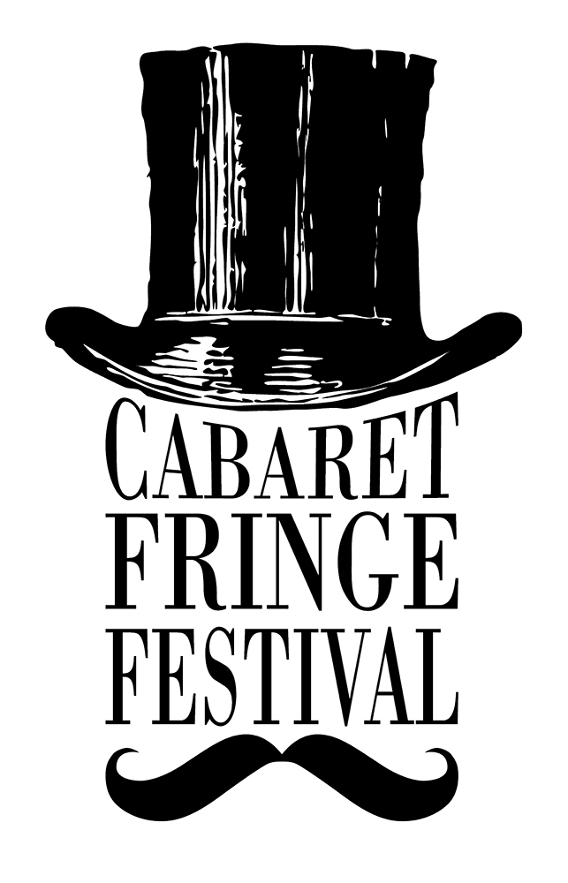
ARTIST REGISTRATION 2017

The following registration form is for artists and companies wishing to participate in the 2017 Cabaret Fringe Festival.

The Cabaret Fringe Festival is an annual open access festival in Adelaide, South Australia. The 2017 Festival will run at various venues around Adelaide from 3rd – 25th June 2017.

Cabaret Fringe uses a rolling registration. This means you can register your event at any time and it will be added to the event listings on the Cabaret Fringe website shortly after we receive the completed registration, provided the registration fee has been paid.

The sooner you complete all your event information and pay the registration fee, the sooner the event will be listed on the CabFringe website and the sooner tickets will be on sale.

Your event will be included in the printed guide if you have registered your event (and paid the registration fee) by 5pm Friday 14TH April. After that, you’ll have an online listing only.

Items marked with an asterisk (*) indicate compulsory information

* CONTACT DETAILS

Primary Contact Person:

Contact Phone:

Email Address:

Postal Address:

Have you participated in the Cabaret Fringe Festival before?
Yes No

Social Media
(Please list any show-relevant accounts you have and include full web address, e.g. www.instagram.com/cabfringe)

Facebook:

Twitter:

Instagram:

Website:

FINANCIAL INFORMATION
We require your financial information to enable us to pay your ticketing income to you at the conclusion of the festival.
*ABN (If you don’t have an ABN we will provide you with an ATO ‘Statement by a Supplier’ form):

* Bank Account details

Please check this information carefully!

- Name account is held under:

- Bank Name:

- Branch Name:

- BSB Number:
(Must be six digits)

- Account Number:

REGISTRATION FEES:
Up to and including 3 performances = $180.30 per event
4+ performances = $250.30
(includes a .30c per event TryBooking admin fee)
To pay with a credit card/debit card, please visit this TRYBOOKING link: https://www.trybooking.com/OPMK

For alternative payment methods, please contact the CabFringe office.

ABOUT YOUR PRODUCTION

Presenter (will be included in the event listing):

*Title of Show:

Artists involved (depending on space, these will be included in the Programme Guide):

*Description (50 words maximum)

*Show duration:

*Content Rating
What ages is your show suitable for? (please select one option)
- All ages
- 15+
- 18+

* Venue
Have you confirmed a performance venue?
- Yes
- No
If you have not yet confirmed a venue, leave the rest of the Venue section blank. You can provide those details at a later date. Please note that your registration is not complete until you provide your venue and session dates and times.

*Venue Contact person & phone number:

*Venue Name:

*Venue Address:

Session Details

Only complete this page if your season (including all session dates/times) has been confirmed with your venue.

- Please indicate below the number of tickets available for each session. This may differ from the venue’s maximum capacity
- Please also indicate the number of tickets you wish to hold on to for your own use, to give to family & friends, etc.

Show No. | Performance Date | Time (please indicate AM or PM) | No. of tix on sale | Tix held for own use
1
2
3
4
5
6
7
8
9
10

If you’re presenting more than 10 performances, please contact us with the details.

*VENUE MAXIMUM CAPACITY:

You may need to contact your venue for specific details.

*Ticket Types
- Enter below each ticket type you wish to make available for purchase.
Please note:

For the CabFringe to be able to run the festival, we charge artists a fee of $3.30 for every ticket sold through TryBooking.

Your ticket prices must be inclusive of this fee.

If your event is free, write "Free" in the Full Price box

- Please note: Cabaret Fringe participates in the Companion Card scheme for all performances. Companion Card is a card issued to people with a permanent disability who require attendant care support which allows a companion to enter free of charge when the person with a disability has a valid ticket.

Ticket Type | Ticket Price
Preview (for early performances only) | $
Adult | $
Concession (Student / Pensioner / Unemployed) | $
Fringe Member (formerly TREv. For more info see www.adelaidefringe.com.au/fringe-membership.) | $
Groups (available for group bookings of 6) | $
Artist (discount price available to other Cabaret Fringe artists & members) | $
Child (Under 15 years) | $
Other ticket type (e.g. Early bird, special, etc. Please indicate which) | $

Media Tickets
Do you authorise Cabaret Fringe to issue complimentary tickets to media outlets for review
purposes? Please note, not all shows may be reviewed.
Do you have any special instructions regarding media ticketing? E.g. You may wish to restrict which media outlets receive comps to your show.
Yes No
If yes, please provide details:

PROMOTIONAL DETAILS
The following information or promotional materials are required by the Cabaret Fringe Festival to sell your show to the public. Some information is essential (indicated with a *). Other information is useful in promoting your event.

Please tick the box below if you are able to provide the content:

- * Event Image (300dpi, minimum 1000 pixels wide/high)
- Artist Biographies (150 t0 200 words max)
- Other promotional photos, other than event image (png or jpeg images)
- Show Reel videos (provide online link or low resolution copy)

All photographs, short videos and documents may be deposited in the Cabaret Fringe Drop Box or emailed to info@cabaretfringefestival.com.

Terms & Conditions
Conditions of Cabaret Fringe Festival Registration:
- The number of performances, session times and venue are solely at the discretion of the organisers/venues.
- The Cabaret Fringe Festival logo will appear on all printed material promoting your event.
- Any images provided for use in the Cabaret Fringe Festival program are provided with full permission of the copyright owner
- A limited number of tickets may be held for Sponsors of the Cabaret Fringe Festival and Press Reviewers etc. this will be limited to 4 tickets per performance unless additional permission is given. Tickets will not be unreasonably withheld or demanded by either party.
- In the event of event cancellation a representative of the Event will be present at the advertised time and venue to apologise to any members of the public who may attempt to attend the event.
- Registered participants agree to complete a Cabaret Fringe Event Survey at the completion of the Festival.
- All venue hire and technical hire & staff costs are the responsibility of the presenter (artist/company)
- Cabaret Fringe Festival does not manage venues or seasons. It is the responsibility of the artist/presenter to make all arrangements directly with venue.
- Submission of this form and payment of the registration fee constitutes an agreement to perform the Event as outlined in this document. Cancellation of the Event is entirely at the discretion of the Festival/Venue and fees are not refundable.

Confirmation of Terms *

I have read the conditions of registration and AGREE

Confirmation of Artists Information *

Before you submit, you must read "Artists Information" document

Yes, I have read the document

No, I haven't read the document
Bottom of Form

Signed by the Presenter:

PRINT NAME:

COMPLETED THE FORM?

Return it to Cab Fringe via:
- Email to info@cabaretfringefestival.com
- Post to 79 Wilpena Tce, Kilkenny SA 5009

PLEASE REMEMBER TO RETAIN A COPY FOR YOUR OWN RECORDS.

